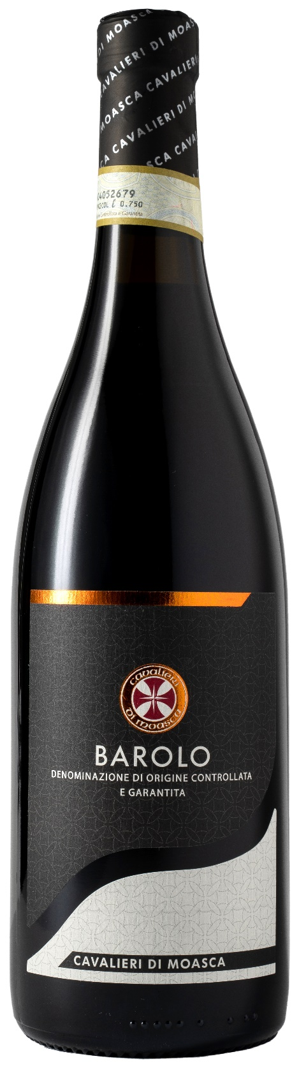
BAROLO DOCG – CAVALIERI DI MOASCA

Grape: Nebbiolo 100%
Alc. Vol.%: 14,5
Vintage: 2022
Residual sugar g/l: 1,1
Total acidity g/l: 5,9
Region: Piedmont
Production zone: Vineyards in the Barolo area (Cuneo)
Capacity: 750ml

CHARACTERISTICS

Vinification: Traditional peel maceration of 12 days in steel tanks at a controlled temperature
Aging: 36 months in oak barrels and steel tanks
Yield per ha: 8000kg
Colour: Bright red with garnet reflections
Bouquet: Rich, elegant, complex and essential
Flavour: Dry, full-bodied with a long-lasting finish

SERVING SUGGESTIONS

Best enjoyed with truffle courses, venison and roasts.
Serving temperature 18-20 °C, to be decanted.
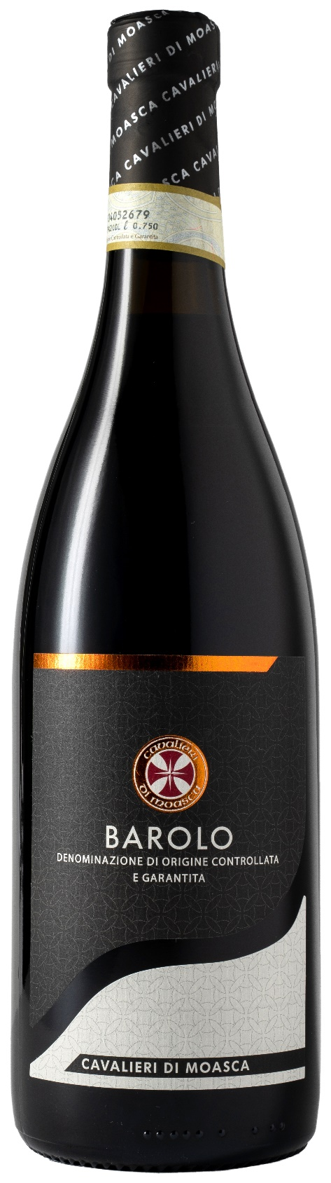
TECHNICAL INFORMATION / PALLETIZING

Size 750ml:
Article Nr. V06001A
GTIN-13 bottle 8017868000181
GTIN-13 carton 8017868002154
Closure Cork
Bottles / carton 6 bottles
Pallet size 80x120cm
Cartons/layer 21
Cartons/pallet 105
Kg/carton 8,1
Kg/pallet 870

Contains sulphites
GMO Free
Revisione 02. 01.10.2026

